**Assessment:**

**Data Visualisation and Storytelling &** **Power BI**

| **Section B (70 points total)** |
| --- |

**Covid-19 Visualizations using Power BI**

Coronavirus disease (COVID-19) is an infectious disease caused by a newly discovered coronavirus. Common symptoms include fever, cough, fatigue, shortness of breath, and loss of smell and taste. While the majority of cases result in mild symptoms, some progress to acute respiratory distress syndrome (ARDS) likely precipitated by a cytokine storm, multi-organ failure, septic shock, and blood clots. Protect yourself and others from infection by washing your hands or using an alcohol-based rub frequently and not touching your face.

Global efforts at this time are focused concurrently on containing the spread and mitigating the impact of this virus. As the coronavirus spreads globally, it will be beneficial to all stack-holders to track the confirmed cases, deaths, and recoveries so that the world can take well informed actions.

Your team is given a series of data, supplied by the UK Government, to perform the Power BI visualization which will help users to understand the whole condition. The CSV files are provided in [this folder.](https://drive.google.com/drive/folders/13lL_2x-euIo_5m8TEVdLvVXrFUYLl-La?usp=sharing)

The senior data analyst has earlier created a dashboard in Power BI for presenting the information from the csv files. However, the source files are lost, and only some screen captures are available now. You are required to recreate similar dashboards in Power BI.

The five dashboard captures are shown below

**1. Deaths UK** (*14 points*)

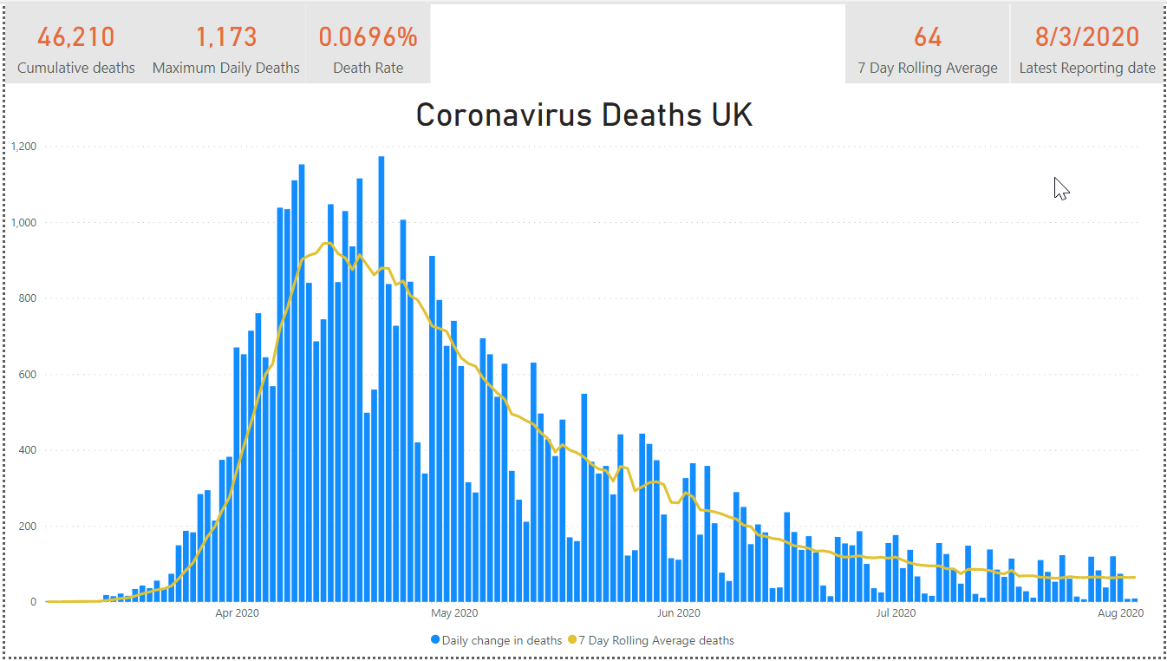

**2. Deaths UK by Nation** (*14 points*)

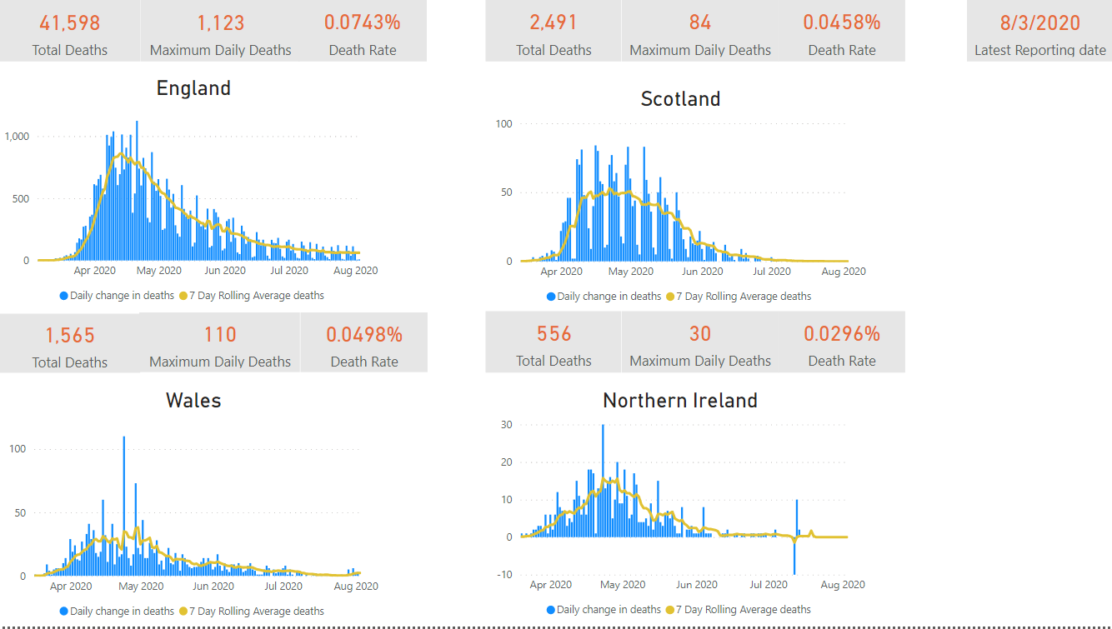

**3. ONS / Gov Deaths England/Wales** (*14 points*)

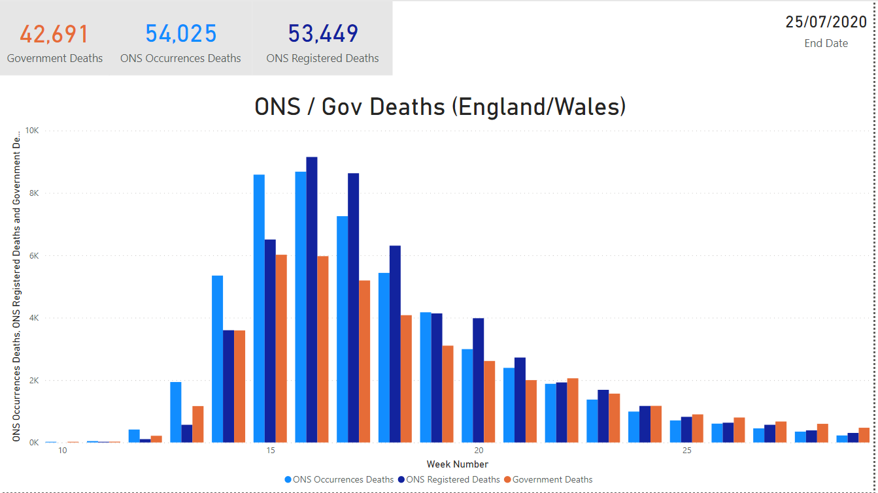

**4. UK Excess Deaths** (*14 points*)

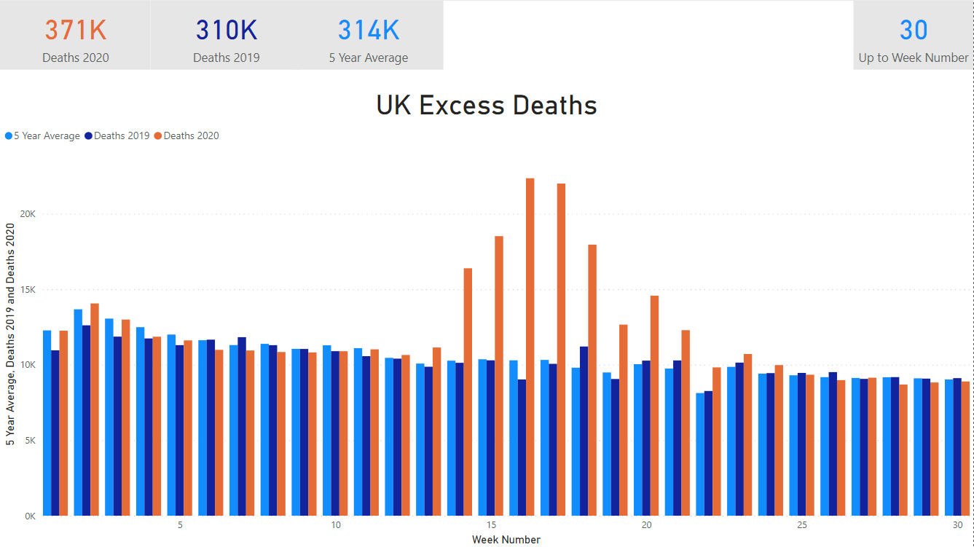

**5. UK Positive Cases Pillar 1 & 2** (*14 points*)

